Git operations:

**ANSWER:**

**Step 1.** To create directory (mkdir)



**Step 2. (**cd) to enter in the directory



**Step 3.** Give touch to create new file



**Step 4.** Give git init to create a git repository

**Step 5.** git add to add the file to the staging area



**Step 6.** Check the status using git status comment

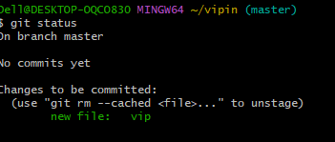

**Step 7.** Give git commit –m to move the file from staging to

local repository

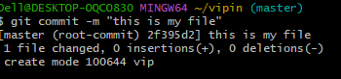

**STEP 8.** Give git log for the details

